PERFORMANCE TESTING

JMeter

* Performance testing tool
* Provided by Apache
* It is an open source and is written in java
* Results are n the form of graph, chart etc.
* JMeter can be integrated with selenium for automated testing.

Installation.

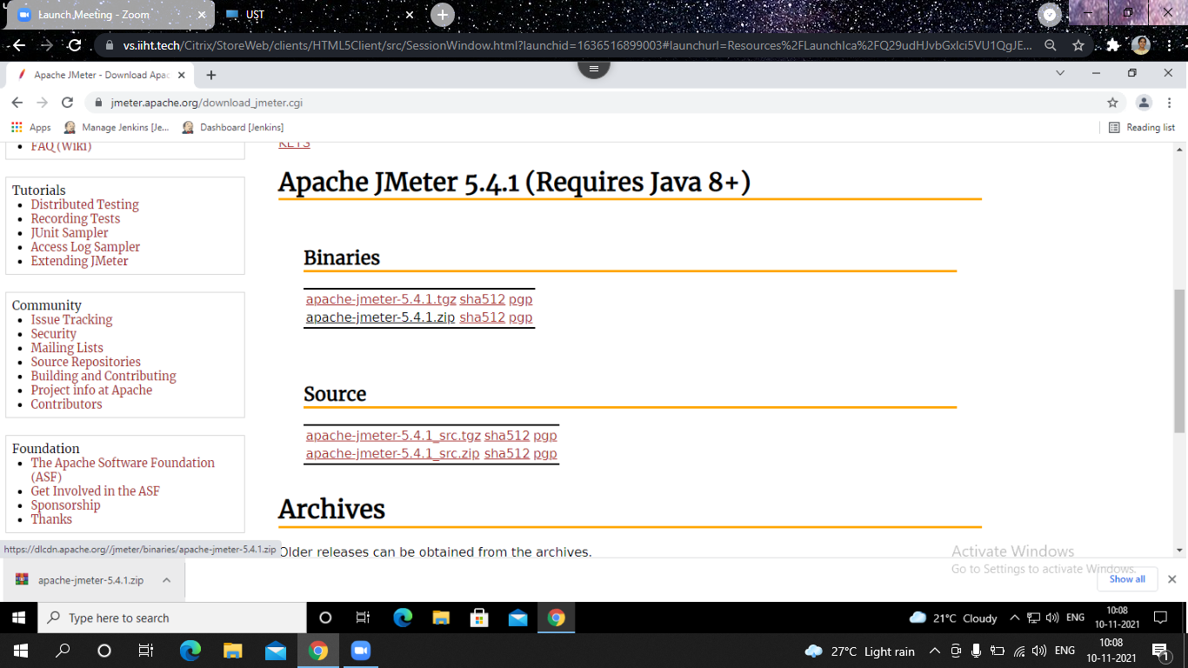

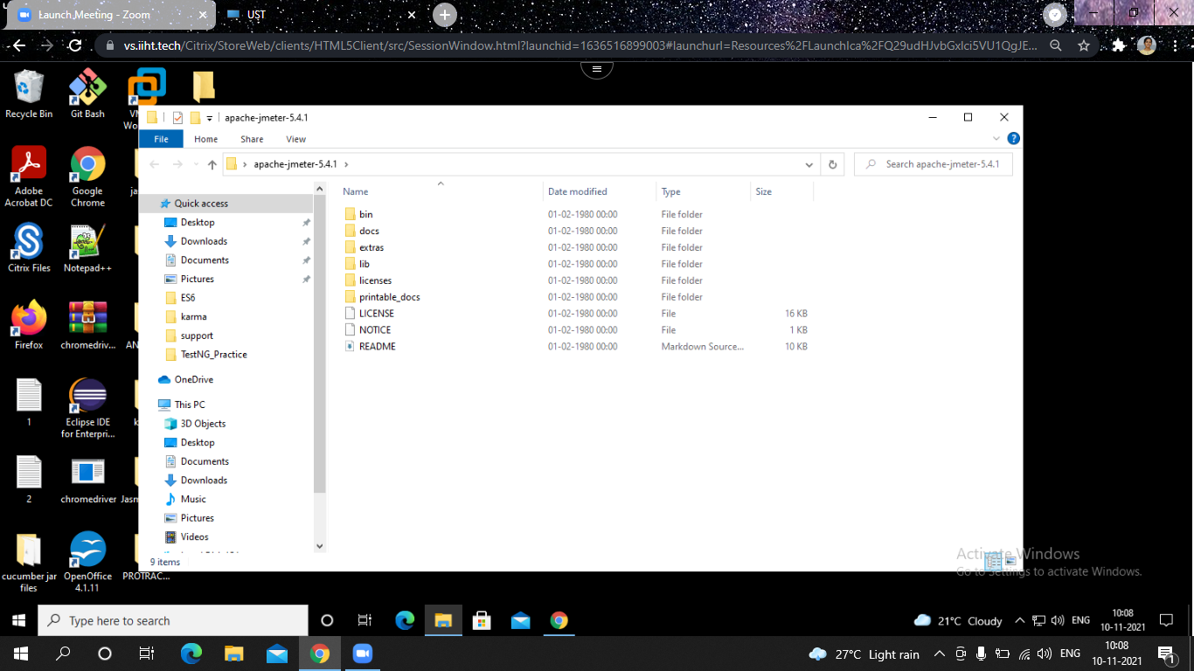

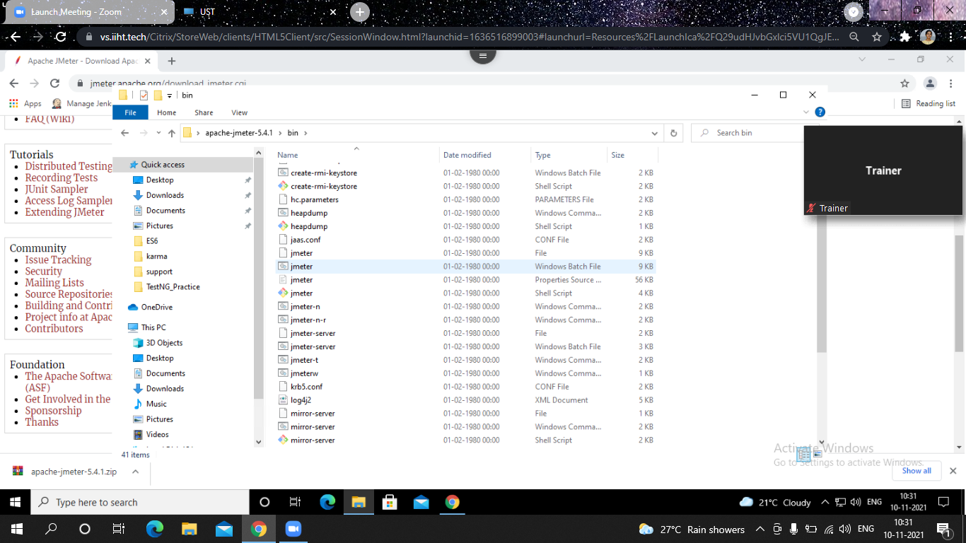

The following image shows the default Apache JMeter interface -

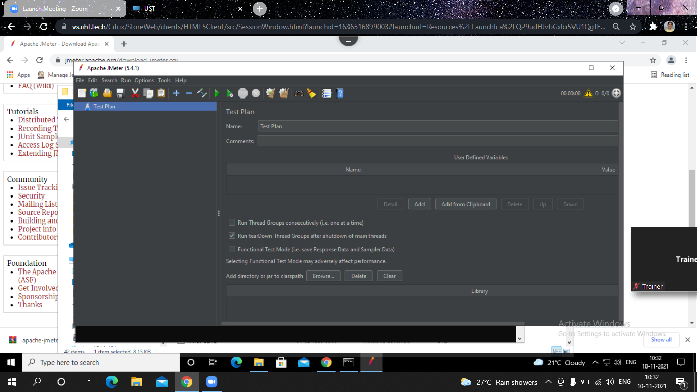

Working of JMeter

JMeter sends requests to a target server by simulating a group of users. Subsequently, data is collected to calculate statistics and display performance metrics of the target server through various formats.

JMeter work flow Diagram:

